**VISVESVARAYA TECHNOLOGICAL UNIVERSITY**

BELAGAVI, KARNATAKA-590014

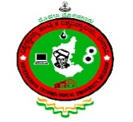

##### DBMS MINI PROJECT REPORT ON

##### **HUMAN RESOURSCE MANAGEMENT SYSTEM**

##### 

###### **Submitted by**

**KAVYA S 4DM15CS016**

**UNDER THE GUIDANCE OF**

**Mr. Pandu NaikB.E.,M.Tech.**

**Assistant Professor & HOD, Dept of ISE**

***In partial fulfillment for the award of the degree of***

##### BACHELOR OF ENGINEERING

IN

COMPUTER SCIENCE AND ENGINEERING



### YENEPOYA INSTITUTE OF TECHNOLOGY

N.H.13, Thodar, Vidyanagar, Moodbidri, Mangalore, Karnataka 574225

2017-2018